Introduction
With a number of apartment buildings, a swimming pool, an industrial park, and a state funded university all in the vicinity of Dry Run Creek there are a number of effluent pipes which empty into this stream. There is a high likelihood that any number of these pipes could contain an effluent that is detrimental to the water quality of the stream. However, the actual source of these effluent pipes is unknown, so predictions of sources were made solely on location of the pipes and their surrounding buildings.
In order to determine the nature of the effluent being discharged into this stream from the effluent, water testing was done upstream and downstream of the effluent pipes. Similarly water was sampled directly from the effluent pipes. The parameters tested for were dissolved oxygen, temperature, conductivity, pH, total dissolved solids, and turbidity.
Goals and Objectives
Our Primary goal of this study was to establish a group project acceptable for completion of the Field and Laboratory Methods in Hydrology class instructed by Dr. Mohammad Iqbal. Secondarily our goal was to determine if any and what affect the effluent pipes surrounding and emptying into Dry Run Creek have on the overall water quality of the stream. The decision to sample multiple times over a month long period would allow us to eliminate any non-typical results. No drastic affects were expected, however if they were noted this would make for an excellent project for additional research.
Importance of Work
Prior research has shown that Dry Run Creek lacks abundance and diversity of aquatic life. Due to this it was placed on the impaired water body list in 2002. The cause for this impairment is suggested to be due to its connection to the Cedar Falls sewer drain system however the substantiality of this effect is unknown.(Kittle) Though our research is limited to three sites, it is still important in the fact that it can show the effects that the effluents might have on Dry Run Creek. Limited effects would suggest that Dry Run Creek is impaired more by water runoff or other causes not associated to these effluent pipes. This would provide basic information for a future, more in depth research study.

Study Area
Dry run creek is a second and third order stream that originates west of Cedar Falls in an agricultural area. There are two separate branches discussed in this paper, all of which ultimately join together and flow into the Cedar River. Along these branches, three effluent pipes were located and deemed a site of interest. At each of these effluent pipes two study sites were established, one downstream from the pipe and one upstream. In each of these cases the upstream site was considered to be the reference site however it was probably not a true reference site as there were more than likely multiple effluents that released upstream from that site. A map of the sampling sites, effluent pipes tested, and the Dry Run Creek area can be seen in Figure 1.
ROTH Site
Study area one was located near the married student housing and the ROTH apartment complex to the south of UNI’s campus. We referred to this location as our ROTH site. The effluent pipe of interest was located on the south bank of the stream and emptied onto a slab of concrete which allowed the water to slowly trickle into the stream. The effluent was guessed to a combination of water runoff and discharge from the married student housing buildings. The banks of the stream were fairly stable however there were downed trees and the bank was relatively steep making access to the effluent difficult. The stream was mostly covered by trees however due to the time of year these trees were mostly leafless. Just upstream from the effluent pipe a natural dam of sticks, leaves, and rocks was present slightly directing the flow of water towards the north bank.

Bike Trail Site
Study area two was located where the same branch of Dry Run Creek passes under University Avenue. At this location the bike trail through Cedar Falls runs right along the stream, due to this we referred to this location as the bike trail site. The effluent of interest was located to the south and just upstream of the University Avenue bridge that passed over the stream. A pipe physically exited the ground from the east and extended over the bank. This allowed for a fairly large and fast moving amount of water to directly enter the stream. The source of this effluent was guessed to be water from the Lutheran Home which was located just east of the stream. There was also another effluent pipe that entered the stream from the west however there was never any visible discharge exiting from the pipe. Our downstream sampling site was located in a riffle just under the bridge and our upstream site was located twenty feet from the pipe. The banks of this area appeared to be stable as there were many trees and bushes to navigate through to get to the stream. The canopy covered most of the effluent and the upstream site as the trees hung over the water. Our downstream site was completely covered by the bridge.
Towers Site
Study area three was located where the north branch of Dry Run Creek passes under Campus Street. This particular location was found near the Towers Dining Center was therefore referred to as the towers site. The effluent pipe of interest exited directly under Campus Street. The water was allowed to enter a pool that later joined up with Dry Run Creek. Water exiting this pipe usually appeared to be very clear. Due to the clearness and the massive quantity of water exiting this pipe it was guessed that the source of the discharge was from waste water leaving either of the two towers and/or the towers dining center. Our upstream site was located fifty feet west in a riffle right next to a stream access from the parking lot located just south of Price Lab. Ducks were often seen swimming in this particular portion of the stream. The banks appeared to be stable as they contained rocks and many grasses and there was very little canopy cover. Our downstream site was located in a marshy-like environment about thirty feet from the effluent. The substrate of this portion of the stream appeared to be fairly sandy and the bank was unstable as it was mostly composed of sand. From the sand grew many grasses which covered nearly the entire bank. There was no canopy cover as there were no trees in this area.
Literature Survey
Pollution can greatly affect the quality of a stream when the source of the pollution is coming from effluent pipes which includes storm water discharge. Water runoff from rain and snow can pick up these pollutants and then carry them into streams and lakes. The pollution source can range from a wide variety of sources. Some of these include automobile fluids, such as oil, gas and, antifreeze, from parking lots and streets. When winter comes around most of Iowa salts its roads, in the spring when the snow melts it then carries this salt through discharge and effluent pipes then into our streams and lakes. This can greatly affect the chloride levels in our water bodies which can be harmful to surround ecosystems. Many cities are required to obtain state permits so that they can discharge storm water into streams and lakes. This can further help the prevention of pollution from discharge of storm water into water bodies.
All of our conductivity and total dissolved solids graphs were almost identically alike. We wanted to find out why this was the case. Total dissolved solids measures the amounts of solids in milligrams per liter of water. Total dissolved solid is also considered to be the sum of cations and anions of the solution. The cations that can occur naturally in water include calcium, magnesium, sodium, potassium, the anions include chloride, sulfate, carbonate and, bicarbonate. Electrical conductivity measures the ability of a substance to conduct or transmit heat, electricity or sound. It also measures the ionic activity between the cations and anions in the way of conductivity.
Materials & Methods
Our methods for collecting our samples consisted of using different tools and instruments to obtain data from our water samples. Our main way of retrieving water from the actual stream was with the seven foot pole with a small cup on the end of it located in the hydrology lab. This gave us an advantage when sampling because we could easily get our water samples from Dry Run Creek without getting into the creek itself. At our site near the towers, the effluent pipe was located about ten feet from actual solid ground so using the pole was a very useful tool. When we were testing the actual water itself for our six different parameters we sometimes just left the water in the cup with the pole to test it. Other times we poured the water we gathered and poured it in our on-site water sampling container we were supplied with in our water sampling kit.
The first location at our study area that we sampled was the effluent pipe itself because we focused mainly around that area at all three of our study areas. At our study area one, ROTH location, we could just take our effluent sample by just holding our onsite container under the effluent pipe to get a good sample of water. At our other two study areas, towers location and University Avenue bike trail location; we had to use the pole with the cup on the end of it to retrieve our water sample because they were not easy to reach.
The next sample we would collect would either be our above or our below water samples. When collecting our above water samples we would always use the pole with the cup on the end of it because it was easier to obtain our samples this way. We collected the above water sample by usually going upstream of the effluent pipe about ten feet unless we had different circumstances that wouldn’t allow us to do so, such as at study area three, Towers location, we had to go on the other side of the road because the bridge was in the way. Our third and final water sample we collected at all three of our study areas was the below sample. We did this similar to our above water samples, by going approximately ten feet below the effluent pipe to collect a water sample.
We collected our samples one by one and tested them in the same manner. The instruments we used to test our parameters were the potential hydrogen meter, dissolved oxygen meter, conductivity & total dissolved solids meter, which was also used to measure temperature and, the turbidity meter. The pH meter and the conductivity & TDS meter were the easiest to use because we had the least trouble with them and they didn’t take a long time to actual give us the data needed. The pH, TDS, conductivity and, temperature were usually the first things tested because it was easy to put these two meters into a cup of water and get our data relatively fast because of the reliability of these two meters. The pH meter was very simple and easy to use, we simply took off the cap of the meter turned on the meter and placed it in the water to get a reading. The TDS and conductivity meter was relatively the same way when using besides the fact that we had to press the mode button for it to change from reading total dissolved solids to conductivity. When using both of these meters we usually waited until the numbers of the readings stopped moving around so that we would get an accurate measurement.
The next parameter that was tested was either the dissolved oxygen or the turbidity of our water samples. When we measured the dissolved oxygen, we would leave the water in the cup with the pole on the end of it because the cup had a wide mouth; this was needed because the dissolved oxygen probe wouldn’t fit in a small mouth container. The dissolved oxygen meter consisted of a meter and a probe. The probe was connected to the meter with a long cable which could be used for lowering it into streams, or other bodies of water from a bridge. We never had to use this method but it would be useful if it was ever needed. When using the dissolved oxygen meter we would first turn on it on and it took a while for it to get connected to the probe. After it was ready we would put the probe into our water sample and press the read button on the meter, it would take up to a minute for us to get a reading from the meter.
Turbidity was usually the last thing we tested for because of the time it took for us to do so. We used the turbidity meter which is stored in plastic case. The meter comes with small glass vials in which we had to fill up to a line that was located on the vials. The meter itself is a small device in which we first had to turn on, which didn’t take very long. We would then put the glass vial full of our sample water into meter, making sure that the arrows on the vial and on the meter would line up so that we would get an accurate measurement. We would then press the read button and it would take around a minute and sometimes even longer to get a reading. Measuring the turbidity usually took the longest out of all of our parameters.
Results
Roth Site
Although no statistical analysis was done we have come up with results that can be visually seen in the graphs located below. It is apparent that TDS and conductivity are directly related as their graphs appear identical. Through this graphical method we can also see that the effluent had a slight effect on pH, TDS, and conductivity. It however was not a profound effect and cannot be seen in all of the dates that were measured.
Bike Trail Site
Although no statistical analysis was done we have come up with results that can be visually seen in the graphs located below. It is apparent that TDS and conductivity are directly related as their graphs appear identical. Through this graphical method we can see that this particular effluent had little to no effect on the stream water quality for the parameters we sampled. Certain parameters saw results on certain dates, however there did not appear to be any trending patterns for this site.
Towers Site
Although no statistical analysis was done we have come up with results that can be visually seen in the graphs located below. It is apparent that TDS and conductivity are directly related as their graphs appear identical. Through this graphical method we can also see that this effluent had a more significant effect on pH, temperature, and turbidity. There was little effect noted for dissolved oxygen, conductivity, or TDS. On the day in which it rained there seemed to be a noticeable difference from the upstream turbidity when compared to the downstream turbidity.
Discussion
From these results we felt as if the effluent most impacting Dry Run Creek was the effluent located at the towers site underneath Campus Street. We felt that this was probably due to the larger volume of water that was being dumped into the stream. This effluent was also located on the northern branch of Dry Run Creek while the other two were located on the middle branch. Although now discharge was calculated, the northern branch appeared to have a far less volume of water flowing through it than did the middle branch. Due to this the effluent under Campus Street was not only dumping a larger volume of water into the stream, but also a larger relative concentration.
None of the effluents seemed to greatly influence the water quality found downstream when comparing it to the reference water of the upstream sites. It was thought that this could be due to the fact that the reference water was not really reference water in the sense that it was probably contaminated from other effluents prior to our sampling site.
At the towers site on the day that it rained the turbidity was found to be much higher downstream than it was upstream. This would be opposite from what we expected due to the fact that the effluent water usually contained very little turbidity. Our thoughts are that the increase in stream discharge due to the rain caused the sandy substrate material found at the downstream site to be stirred up into the water column resulting in a higher turbidity value. This sandy substrate was not found at the upstream site.
We also found a trend over all suggesting that rain had a large impact on the conductivity and total dissolved solid values. This was noted because for the day in which we sampled during the rain these values were much lower. Similarly we found that the turbidity values were much higher. We think this is due to the fact that the rain would wash some of the soil into the stream. The increase in the rate of flow of the water as well as the volume of water would also be likely the stir up the substrate and allow the particles to enter into the water column.
On the night of November ninth Cedar Falls received a small amount of snow which mostly melted the following morning. November tenth we sampled in hopes of seeing the effects that snow melt would have on the effluent pipes. No significant effects were noticed for any of the sites.
None of the sites showed any significant effects on water temperature from the effluents. We do think that the little affect that was seen can be attributed to the shaded vs. the non-shaded portions of the stream. At certain times on certain sites, portions of the stream were shaded which would cool the rocks and ultimately lower the temperature of the water. This was probably most noted when we sampled under bridges. This would also influence the results that we saw from the effect of effluents on the temperatures.
Conclusion
- Towers site had largest effect on stream
  - Largest volume of effluent water
- Overall there was no large effect for the parameters we sampled
- Temperature differences could have been due to shaded vs non shaded areas of the stream
- Rain greatly reduces the conductivity and total dissolved solids while increasing turbidity
- Snow had no effect

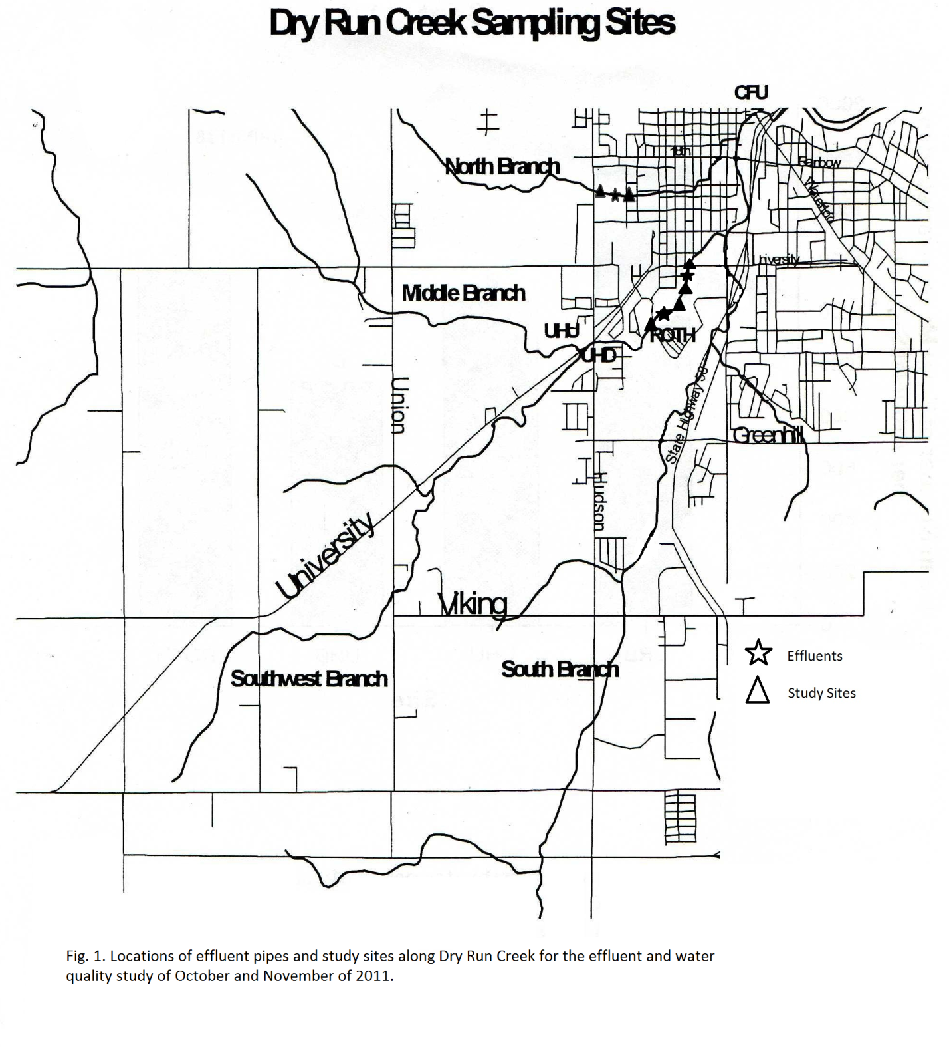

ROTH Site
20-Oct | Above | Effluent | Below
Ph | 8.36 | 8.36 | 8.44
TDS | 409 | 914 | 405
Conductivity | 589 | 1313 | 587
Temperature | 9.2 | 10.3 | 10
DO | 11.93 | 10.59 | 11.18
Turbidity | 2.66 | 0.4 | 4.16

24-Oct | Above | Effluent | Below
Ph | 8.31 | 8.3 | 8.29
TDS | 387 | 986 | 413
Conductivity | 560 | 1423 | 632
Temperature | 14.6 | 17.7 | 15.3
DO | 10.84 | 8.6 | 10.38
Turbidity | 5.15 | 1.15 | 2.33

27-Oct | Above | Effluent | Below
Ph | 8.39 | 8.32 | 8.34
TDS | 418 | 975 | 508
Conductivity | 604 | 1414 | 737
Temperature | 13 | 12.1 | 10.7
DO | 11.46 | 9.17 | 11.04
Turbidity | 12.2 | 9.62 | 6.21

2-Nov | Above | Effluent | Below
Ph | 8.34 | 8.36 | 8.35
TDS | 300 | 153 | 112
Conductivity | 435 | 223 | 163
Temperature | 11.4 | 8.6 | 9.6
DO | 9.36 | 10.38 | 10.39
Turbidity | 46.3 | 46.9 | 37.7

3-Nov | Above | Effluent | Below
Ph | 8.27 | 8.32 | 8.31
TDS | 380 | 690 | 433
Conductivity | 552 | 996 | 628
Temperature | 13.3 | 12.4 | 9.8
DO | 10.75 | 9.64 | 10.77
Turbidity | 9.27 | 13.7 | 4.64

10-Nov | Above | Effluent | Below
Ph | 8.22 | 8.46 | 8.27
TDS | 367 | 630 | 380
Conductivity | 530 | 915 | 551
Temperature | 8.5 | 14.2 | 6.1
DO | 10.73 | 9.89 | 11.16
Turbidity | 12.9 | 8.7 | 23

Bike Trail Site
20-Oct | Above | Effluent | Below
Ph | 8.23 | 8.31 | 8.2
TDS | 434 | 503 | 440
Conductivity | 628 | 726 | 637
Temperature | 10 | 10.8 | 9.9
DO | 10.96 | 9.95 | 10.7
Turbidity | 0.69 | 0 | 0.51

24-Oct | Above | Effluent | Below
Ph | 8.23 | 8.16 | 8.23
TDS | 417 | 445 | 416
Conductivity | 602 | 643 | 603
Temperature | 15.3 | 16.8 | 14.9
DO | 10.36 | 9.15 | 10.35
Turbidity | 3.35 | 0.05 | 5.17

27-Oct | Above | Effluent | Below
Ph | 8.15 | 8.27 | 8.27
TDS | 445 | 493 | 446
Conductivity | 646 | 715 | 647
Temperature | 12.6 | 13.6 | 12.2
DO | 10.22 | 9.24 | 10.46
Turbidity | 6.35 | 4.27 | 4.4

2-Nov | Above | Effluent | Below
Ph | 8.12 | 8.2 | 8.18
TDS | 385 | 76 | 214
Conductivity | 562 | 114 | 311
Temperature | 8 | 7.7 | 8.2
DO | 9.37 | 11 | 10.62
Turbidity | 27.3 | 51.1 | 34.5

3-Nov | Above | Effluent | Below
Ph | 8.27 | 8.09 | 8.26
TDS | 367 | 482 | 391
Conductivity | 541 | 712 | 559
Temperature | 9.1 | 13.3 | 8.6
DO | 10.99 | 9.67 | 10.87
Turbidity | 0.54 | 1.06 | 5.67

10-Nov | Above | Effluent | Below
Ph | 8.32 | 8.25 | 8.29
TDS | 371 | 462 | 375
Conductivity | 543 | 676 | 544
Temperature | 6.1 | 11.7 | 5.9
DO | 11.31 | 9.35 | 11.47
Turbidity | 3.14 | 0.53 | 5.22

Towers Site
20-Oct | Above | Effluent | Below
Ph | 8.43 | 8.35 | 8.38
TDS | 332 | 304 | 318
Conductivity | 465 | 451 | 460
Temperature | 10.8 | 11 | 10.3
DO | 11 | 10.78 | 11.67
Turbidity | 2.49 | 0.77 | 2.11

24-Oct | Above | Effluent | Below
Ph | 8.42 | 7.99 | 8.01
TDS | 400 | 385 | 387
Conductivity | 579 | 560 | 562
Temperature | 13.3 | 15.6 | 14.4
DO | 12.3 | 9.49 | 9.82
Turbidity | 4.6 | 0.12 | 1.55

27-Oct | Above | Effluent | Below
Ph | 8.38 | 8.18 | 8.19
TDS | 394 | 400 | 391
Conductivity | 575 | 587 | 565
Temperature | 13 | 14 | 16.6
DO | 11.86 | 10.16 | 9.77
Turbidity | 14.7 | 1.68 | 0.68

2-Nov | Above | Effluent | Below
Ph | 8.31 | 8.23 | 8.12
TDS | 137 | 57 | 126
Conductivity | 199 | 86 | 187
Temperature | 6.7 | 7.2 | 7.2
DO | 11.28 | 11.87 | 11.2
Turbidity | 37.2 | 24.7 | 55.7

3-Nov | Above | Effluent | Below
Ph | 8.34 | 8.38 | 8.37
TDS | 334 | 338 | 742
Conductivity | 484 | 548 | 1075
Temperature | 8.34 | 8.38 | 10
DO | 11.75 | 11.39 | 10.4
Turbidity | 6.5 | 1.23 | 3.47

10-Nov | Above | Effluent | Below
Ph | 8.38 | 8.36 | 8.39
TDS | 338 | 766 | 345
Conductivity | 490 | 1130 | 492
Temperature | 5.2 | 8.7 | 6.6
DO | 12.49 | 10.45 | 11.24
Turbidity | 5.73 | 2.21 | 4.85

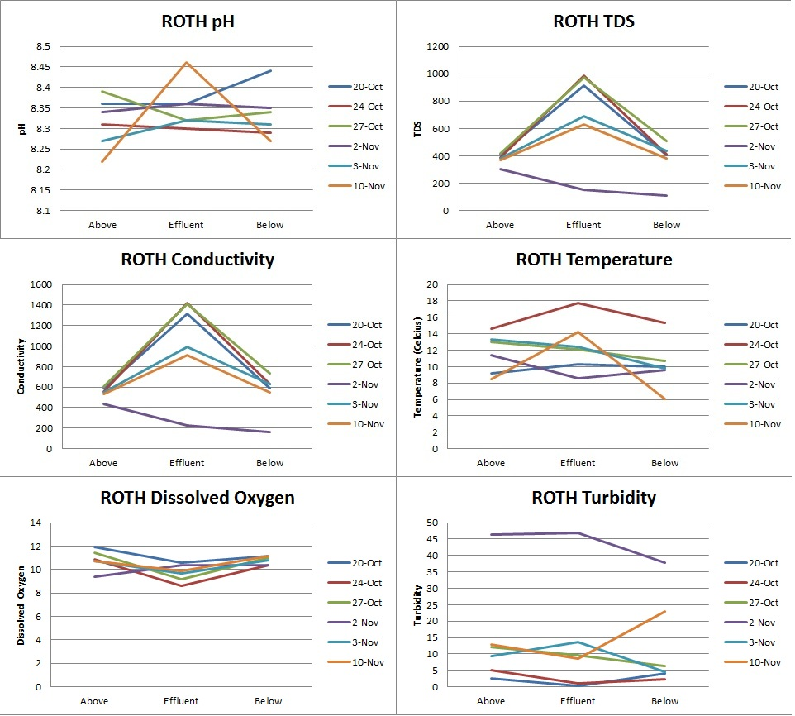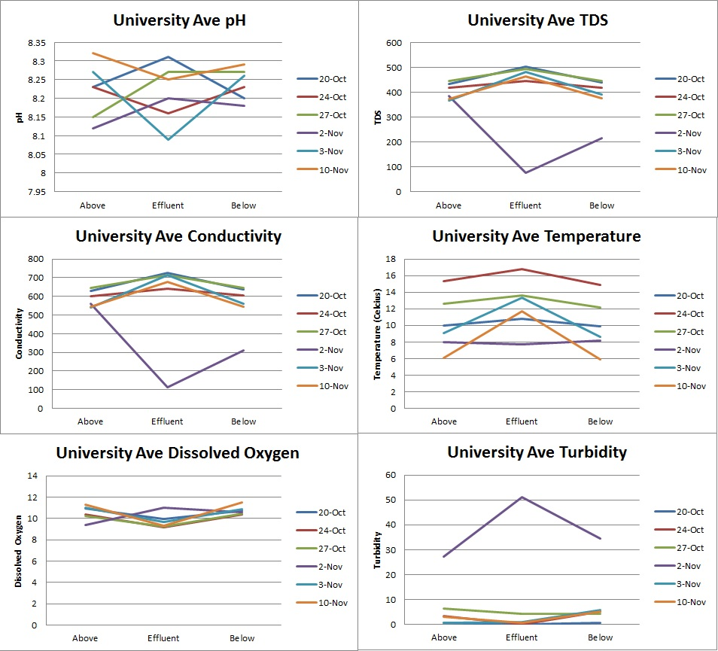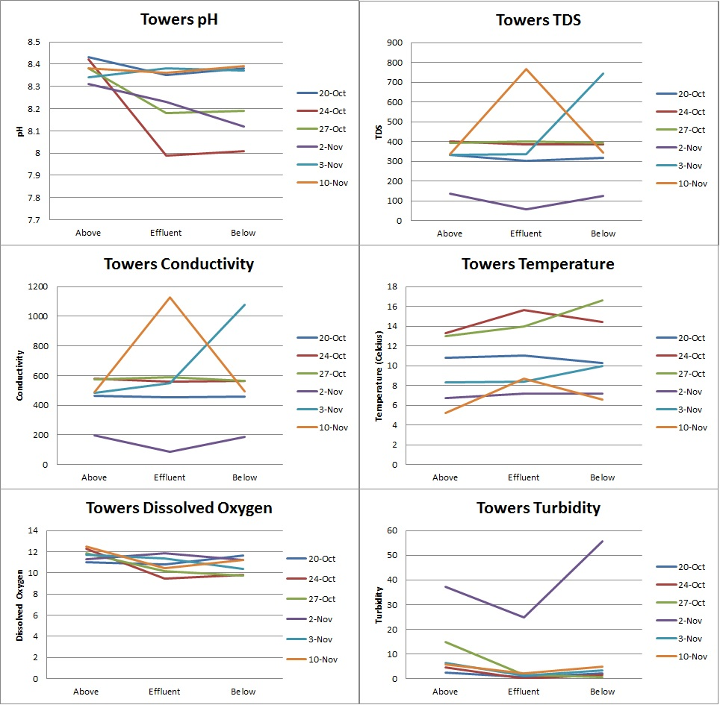

References
Kittle, Ashley. "Dry Run Creek Watershed." BLACK HAWK SOIL AND WATER CONSERVATION DISTRICT. Watershed Conservationist. Web. 07 Dec. 2011. <http://blackhawkswcd.org/Dry_Run_Creek_Watershed.php>.
Liebl, David. "Total Suspended Solids: The Hows and Whys of Controlling Runoff Pollution." Uwex.edu. 2009. Web. 7 Dec. 2011. <http://runoffinfo.uwex.edu/pdf/Runoff-SuspendedSolids.pdf>.
Oram, Brian. "Total Dissolved Solids." Water-research.net. Web. <http://www.water-research.net/totaldissolvedsolids.htm>.
"Water Conductivity - Lenntech." Water Treatment and Purification - Lenntech. Web. 07 Dec. 2011. <http://www.lenntech.com/applications/ultrapure/conductivity/water-conductivity.htm>.

